**MINISTRY OF EDUCATION AND TRAINING**

**FPT UNIVERSITY**

**DOCUMENT REPORT**

Capstone Project Document

**VN Habit Tracker**

|  |  |
| --- | --- |
| **Group 3** | |
| **Group members** | Lưu Thành Đạt - SE61124  Nguyễn Quang Tuyến - SE62069  Nguyễn Hữu Thắng - SE62447  Phạm Thanh Tùng - SE61628 |
| **Supervisor** | Lại Đức Hùng |
| **Ext. Supervisor** | N/A |
| **Capstone Project code** | VHT |

- Ho Chi Minh city, September 14th 2018

# Definitions, Acronyms, and Abbreviations

|  |  |
| --- | --- |
| **Name** | **Definition** |
| VHT | VN Habit Tracker |
|  |  |

# Software Requirement Specification

* + - 1. **User Requirement Specification**
  1. Guest Requirement

Guest is a person who doesn’t have access to the system. Guest can use some functions in the system. To use all functions, guest must login. These are some functions that guest can use:

• Login.

* Register.
  1. User Requirement

User is a guest who logged into the system with user’s role. There are some functions that user can use:

* Manage habit

+ View habit

+ Delete habit

+ Edit habit

+ Add habit

+ Check time habit

* Manage goal

+ Add goal

+ Delete goal

+ Edit goal

* Manage settings

+ Set goal

+ Set reminders

+ Set sound

+ Feedback and contact

* View statistics
* Logout
  1. Admin Requirement

Admin is the person who manages the system, a super user of system. There are some functions admin can use:

* Manage user

+ View user

+ Reset password

* Manage feedback

+ View feedback

+ Reply feedback

1. **System Requirement Specification**
   1. External Interface Requirement
      1. User Interface

* General requirement for graphics user interface is the GUI should be simple, clear, intuitive, and reminiscent.
* The interface design is an iterated process includes design, sketching and user assessment.
  + 1. Hardware Interface
* Smartphone, desktop, laptop or tablet has the ability to connect to the internet.
* The system will use the standard hardware and data communications resources of a standard computer.
  + 1. Software Interface
* Run with Chromes (v60 or above), Firefox (v46.1 or above)
* The screen must bigger than 1024x768.
* Mobile application: Android studio (version 3.1.4), Genymotion (version 2.12.2).
  + 1. Communication Protocol
* Using HTTP/HTTPS protocol.
  1. System Overview Use Case

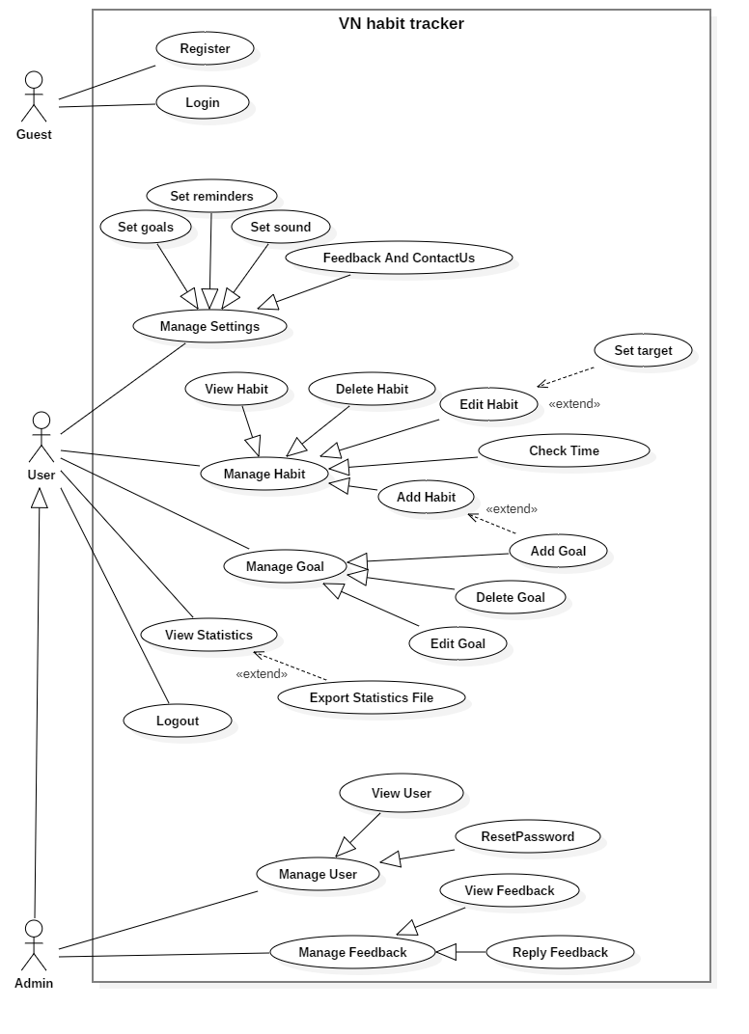

*Figure 2- System Overview Use Case*

* 1. List of Use case
     1. <User> Set goals

**Use Case Diagram**

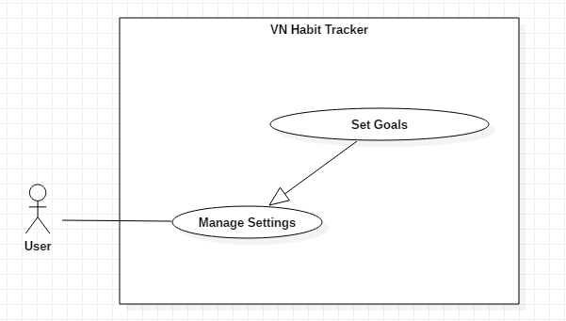

*Figure 5- <User> Set goals*

**Use Case Specification**

|  |  |  |  |
| --- | --- | --- | --- |
| **USE CASE – UC_04** | | | |
| **Use Case No.** | 02 | **Use Case Version** | 1.0 |
| **Use Case Name** | Set goals | | |
| **Author** | TuyenNQ | | |
| **Date** | 27/09/2018 | **Priority** | Normal |
| **Actor:**   * User   **Summary:**   * This use case allows the user set goals.   **Goal:**   * User set goals yourself.   **Triggers:**   * User click on “settings” button. * After that, user click on “Set goals” button.   **Preconditions:**   * Guest must login.   **Post Conditions:**   * **Success:** System shows “Successful to set goals!” messages. * **Fail:** System shows “Failed to set goals” message.   **Main Success Scenario:**   |  |  |  | | --- | --- | --- | | Step | Actor Action | System Response | | 1 | User click on “Set goals” button. | System shows list defaut goals for user choice. | | 2 | User click on “Done” button. | - The system validates the information and shows confirmation message.  [Exception 1] |   **Alternative:**   |  |  |  | | --- | --- | --- | | No | Actor Action | System Response | | 1 | User click on “cancel” button. | Close this form. |   **Exceptions:**   |  |  |  | | --- | --- | --- | | No | Cause | System Response | | 1 | System List goal fail. | System shows “Error!” message |   **Relationships:**  N/A  **Business Rules:**   * After set goals success. The user will return to the settings page. * User can add new goals. | | | |

*Table 15 – Set goals*

* + 1. <User> Feedback and contact us

**Use Case Diagram**

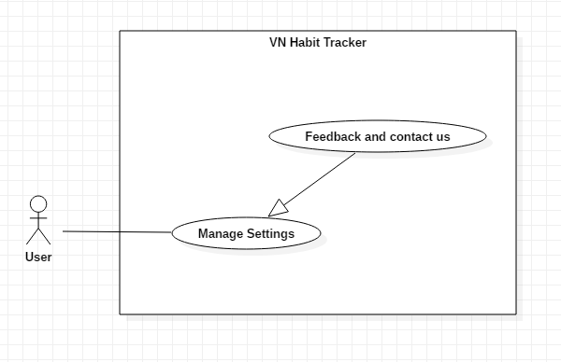

*Figure 6- <User> Feedback and contact us*

**Use Case Specification**

|  |  |  |  |
| --- | --- | --- | --- |
| **USE CASE – UC_04** | | | |
| **Use Case No.** | 03 | **Use Case Version** | 1.0 |
| **Use Case Name** | Feedback and contactUs | | |
| **Author** | TuyenNQ | | |
| **Date** | 27/09/2018 | **Priority** | Normal |
| **Actor:**   * User   **Summary:**   * This use case allows the user set goals.   **Goal:**   * Feedback the application.   **Triggers:**   * User click on “settings” button. * After that, user click on “Feedback and contact us” button.   **Preconditions:**   * Guest must login.   **Post Conditions:**   * **Success:** System shows “successful to feedback!”messages. * **Fail:** System shows “Failed to feedback!” error message.   **Main Success Scenario:**   |  |  |  | | --- | --- | --- | | Step | Actor Action | System Response | | 1 | User click on “Set goals” button. | The system shows a form for user feedback.  + Name: text input  + Your email: text input  + Your email again: text input  + Message: text input | | 2 | User click on “OK” button. | - The system validates the information and shows confirmation message.  [Exception 1] |   **Alternative:**   |  |  |  | | --- | --- | --- | | No | Actor Action | System Response | | 1 | User click on “cancel” button. | Close this form. |   **Exceptions:**   |  |  |  | | --- | --- | --- | | No | Cause | System Response | | 1 | Lost internet. | System shows “Error!” message. | | 2 | The field is not blank. | System shows “must be not blank” message. |   **Relationships:**  N/A  **Business Rules:**   * User can feedback about error, bug,… on application. * After feedback success. The user will return to the settings page. | | | |

*Table 16 – Feedback and contact us*

* + 1. <User> Set reminder

**Use Case Diagram**

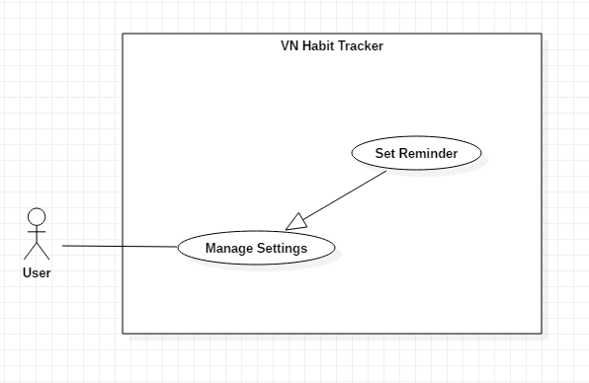

*Figure 7 - <User> Set reminder*

**Use Case Specification**

|  |  |  |  |
| --- | --- | --- | --- |
| **USE CASE – UC_04** | | | |
| **Use Case No.** | 01 | **Use Case Version** | 1.0 |
| **Use Case Name** | Set reminder | | |
| **Author** | TuyenNQ | | |
| **Date** | 27/09/2018 | **Priority** | Normal |
| **Actor:**   * User   **Summary:**   * This use case allows the user set sounds.   **Goal:**   * Set reminder for user.   **Triggers:**   * User click on “settings” button. * After that, user click on “Set reminder” button.   **Preconditions:**   * Guest must login.   **Post Conditions:**   * **Success:** System shows list reminder messages. * **Fail:** System shows error message.   **Main Success Scenario:**   |  |  |  | | --- | --- | --- | | Step | Actor Action | System Response | | 1 | User click on “Set reminder” button. | The system shows a form for use set reminder.  + General app reminder: list reminder  + reminder sound: list option  + Snooze time: list option | | 2 | User click on “Done” button. | - The system validates the information and shows confirmation message.  [Exception 1] |   **Alternative:**   |  |  |  | | --- | --- | --- | | No | Actor Action | System Response | | 1 | User click on “cancel” button. | Close this form. |   **Exceptions:**   |  |  |  | | --- | --- | --- | | No | Cause | System Response | | 1 | System shows list reminder fail. | System shows “Error!” message |   **Relationships:**  N/A  **Business Rules:**   * After set reminder success. The user will return to the settings page. * Only use sound defaut to set reminder. * The maximum snooze time is 24 hours. | | | |

*Table 17 – Add habit specification*

* + 1. <User> Add habit

**Use Case Diagram**

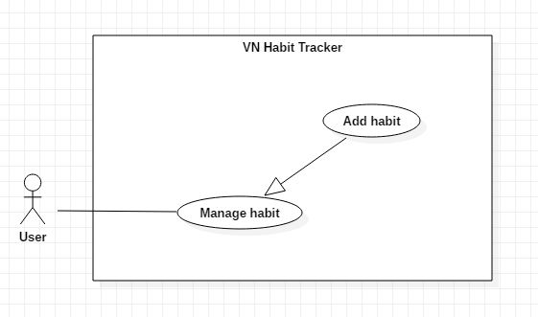

*Figure 8- <User> Add habit*

**Use Case Specification**

|  |  |  |  |
| --- | --- | --- | --- |
| **USE CASE – UC_01** | | | |
| **Use Case No.** | 01 | **Use Case Version** | 1.0 |
| **Use Case Name** | Add habit | | |
| **Author** | TuyenNQ | | |
| **Date** | 27/09/2018 | **Priority** | Normal |
| **Actor:**   * User   **Summary:**   * This use case allows the user to add a new habit.   **Goal:**   * Add a new habit from the schedule.   **Triggers:**   * User click on “Add habit” button.   **Preconditions:**   * Guest must login.   **Post Conditions:**   * **Success:** System shows “Successful to add a new habit!” message. * **Fail:** System shows “Failed to add a new habit!” message.   **Main Success Scenario:**   |  |  |  | | --- | --- | --- | | Step | Actor Action | System Response | | 1 | User click on “Add habit” button. | The system request information in form:   * Habit name: input text * Habit type: input text * Habit color: select button * Habit goal: select option * Start date: datetime * End date: datetime | | 2 | User click on “OK” button. | - The system validates the information and shows confirmation message.  [Exception 1, 2] | | 3 | User click on “Save” button | - System shows “Successful to add a new habit” message |   **Alternative:**   |  |  |  | | --- | --- | --- | | No | Actor Action | System Response | | 1 | User click on “Cancel” button. | - Close this form. |   **Exceptions:**   |  |  |  | | --- | --- | --- | | No | Cause | System Response | | 1 | User add an existed habit in the application | Show message to notify user this habit is existed. | | 2 | User add new fail | System shows “Failed to add a new habit!” message. |   **Relationships:**  N/A  **Business Rules:**   * The habit’s name must be under 255 characters and not null. * After adding habit success. The user returns to the habit page. | | | |

*Table 18 – Add habit*

* + 1. <User> Delete habit

**Use Case Diagram**

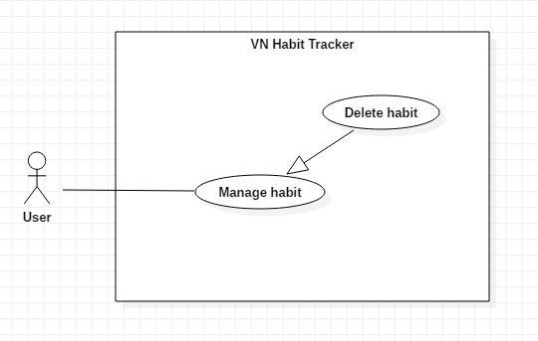

*Figure 9 - <User> Delete habit*

**Use Case Specification**

|  |  |  |  |
| --- | --- | --- | --- |
| **USE CASE – UC_02** | | | |
| **Use Case No.** | 02 | **Use Case Version** | 1.0 |
| **Use Case Name** | Delete habit | | |
| **Author** | TuyenNQ | | |
| **Date** | 27/09/2018 | **Priority** | Normal |
| **Actor:**   * User   **Summary:**   * This use case allows the user to delete a habit.   **Goal:**   * Delete a habit from the schedule.   **Triggers:**   * User click on “Delete habit” button.   **Preconditions:**   * Guest must login. * The habit is existed.   **Post Conditions:**   * **Success:** System shows “Successful to delete the habit!” message. * **Fail:** System shows “Failed to delete this habit!” message.   **Main Success Scenario:**   |  |  |  | | --- | --- | --- | | Step | Actor Action | System Response | | 1 | User click on “Delete habit” button. | Shows a form to ask user want to delete habit. | | 2 | User click on “OK” button. | - The system validates the information and shows confirmation message.  [Exception 1] | | 3 | User click on “Yes” button. | - That habit will be deleted. |   **Alternative:**   |  |  |  | | --- | --- | --- | | No | Actor Action | System Response | | 1 | User click on “Cancel” button. | - Close this form. |   **Exceptions:**   |  |  |  | | --- | --- | --- | | No | Cause | System Response | | 1 | None of any habit was selected | Shows “Failed to delete a habit!” message. |   **Relationships:**  N/A  **Business Rules:**   * When a user deleted a habit, this habit will be hidden. * The information of the habit is deleted to the local. | | | |

*Table 19 – Delete habit*

* + 1. <User> Edit habit

**Use Case Diagram**

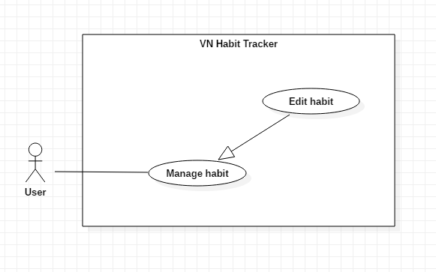

*Figure 10 - <User> Edit habit*

**Use Case Specification**

|  |  |  |  |
| --- | --- | --- | --- |
| **USE CASE – UC_03** | | | |
| **Use Case No.** | 03 | **Use Case Version** | 1.0 |
| **Use Case Name** | Edit habit | | |
| **Author** | TuyenNQ | | |
| **Date** | 27/09/2018 | **Priority** | Normal |
| **Actor:**   * User   **Summary:**   * This use case allows the user to edit a habit.   **Goal:**   * Edit habit when user input.   **Triggers:**   * User click on “Edit habit” button.   **Preconditions:**   * Guest must login. * The habit is existed.   **Post Conditions:**   * **Success:** System shows “Successful to edit a habit!” message. * **Fail:** System shows “Failed to edit a habit!” message.   **Main Success Scenario:**   |  |  |  | | --- | --- | --- | | Step | Actor Action | System Response | | 1 | User click on “Edit habit” button. | The system request information in form:   * Habit name: input text * Habit type: input text * Habit color: select button * Habit goal: select option * Set a target: datetime | | 2 | User click on “OK” button | - The system validates the information and shows confirmation message.  [Exception 1, 2] | | 3 | User click on “YES” button | - System shows “Successful to edit a habit!” message. |   **Alternative:**   |  |  |  | | --- | --- | --- | | No | Actor Action | System Response | | 1 | User click on “Cancel” button. | - Close this form. |   **Exceptions:**   |  |  |  | | --- | --- | --- | | No | Cause | System Response | | 1 | The field is blank | The system shows “Must not be blank!” message. | | 2 | System edit habit fail | System shows “Failed to edit a habit!” message. | |  |  |  |   **Relationships:**  N/A  **Business Rules:**   * The habit’s name must be under 255 characters and not null. * The information of Habit is sent to the server. * After Edit habit success. The user will return to the habit page. | | | |

*Table 20 – Edit habit*

* + 1. <User> View habit

**Use Case Diagram**

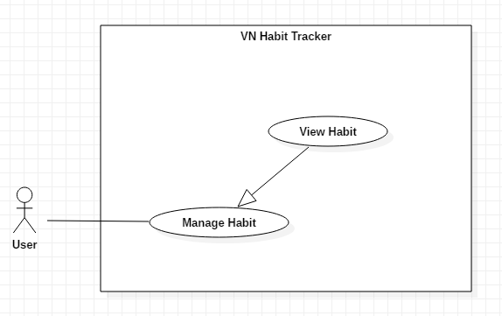

*Figure 11 - <User> View habit*

**Use Case Specification**

|  |  |  |  |
| --- | --- | --- | --- |
| **USE CASE – UC_04** | | | |
| **Use Case No.** | 04 | **Use Case Version** | 1.0 |
| **Use Case Name** | View habit | | |
| **Author** | TuyenNQ | | |
| **Date** | 27/09/2018 | **Priority** | Normal |
| **Actor:**   * User   **Summary:**   * This use case allows the user to view all habit are added.   **Goal:**   * View habit when user want to see their added habit.   **Triggers:**   * User click on “View habit” button. * User click on “Login habit” button.   **Preconditions:**   * Guest must login. * The habit is existed.   **Post Conditions:**   * **Success:** System shows all habit are added. * **Fail:** User can’t see their added habit.   **Main Success Scenario:**   |  |  |  | | --- | --- | --- | | Step | Actor Action | System Response | | 1 | User click on “View habit” button.  User click on “Login” button | The system show information in form:   * Habit name: text * Habit description: text * Habit color * Habit goal: text * Habit time: date time | | 2 | User click on “View habit” button | - The system validates the request and shows the added habit.  [Exception 2] |   **Exceptions:**   |  |  |  | | --- | --- | --- | | No | Cause | System Response | | 1 | There are no existed habit | The system shows nothing | | 2 | System login habit fail | System shows “Please reconfirm your password!” message. | |  |  |  |   **Relationships:**  N/A  **Business Rules:**   * The habit’s information must be existed first. * The information of Habit is sent to the server. * After View habit successfully. The user will see the list of all habit. | | | |

*Table 21 – View habit*

* + 1. <User> Set notification

**Use Case Diagram**

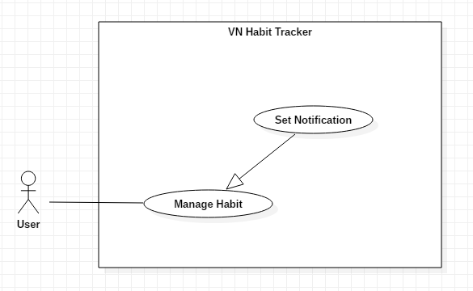

*Figure 12 - <User> Set notification*

**Use Case Specification**

|  |  |  |  |
| --- | --- | --- | --- |
| **USE CASE – UC_05** | | | |
| **Use Case No.** | 05 | **Use Case Version** | 1.0 |
| **Use Case Name** | Set notification | | |
| **Author** | TuyenNQ | | |
| **Date** | 27/09/2018 | **Priority** | Normal |
| **Actor:**   * User   **Summary:**   * This use case allows the user to set the notification.   **Goal:**   * Set notification for a habit.   **Triggers:**   * User click on “Set notification” button.   **Preconditions:**   * Guest must login. * User click on “Edit habit” button. * User click on “Add habit” button. * The habit is existed.   **Post Conditions:**   * **Success:** Mobile devices will show the pop-up with sound. * **Fail:** Nothing will be showed.   **Main Success Scenario:**   |  |  |  | | --- | --- | --- | | Step | Actor Action | System Response | | 1 | User click on “Set notification” button. | The system request information in form:   * Habit name: text * Habit description: text * Habit time: date time * Snooze length * Sound | | 2 | User click on “OK” button | - The system validates the request and shows the added information.  [Exception 1, 2] | | 3 | User click on “Yes” button | System shows “Successful to edit a habit!” message. |   **Alternative:**   |  |  |  | | --- | --- | --- | | No | Actor Action | System Response | | 1 | User click on “Cancel” button. | - Close this form. |   **Exceptions:**   |  |  |  | | --- | --- | --- | | No | Cause | System Response | | 1 | The field is blank | The system shows “Must not be blank!” message. | | 2 | System fail to set notification | System shows “Failed to set notification!” message. | |  |  |  |   **Relationships:**  N/A  **Business Rules:**   * The habit must be existed first. * After set notification successfully. The user will see the notification of the habit when time comes. | | | |

*Table 22 – Set notifcation*

* + 1. <User> Add goal

**Use Case Diagram**

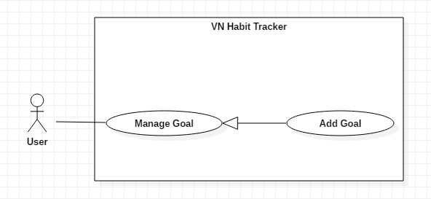

*Figure 13 - <User> Add goal*

**Use Case Specification**

|  |  |  |  |
| --- | --- | --- | --- |
| **USE CASE – UC_0** | | | |
| **Use Case No.** | 0 | **Use Case Version** | 1.0 |
| **Use Case Name** | Add goal | | |
| **Author** | TungPT | | |
| **Date** | 07/10/2018 | **Priority** | Normal |
| **Actor:**   * User   **Summary:**   * This use case allows the user to add goal.   **Goal:**   * Add a goal while add the habit.   **Triggers:**   * User click on “Add goal” button.   **Preconditions:**   * Guest must login.   **Post Conditions:**   * **Success:** System shows “Successful to add a goal!” message. * **Fail:** System shows “Failed to add a goal!” message.   **Main Success Scenario:**   |  |  |  | | --- | --- | --- | | Step | Actor Action | System Response | | 1 | User click on “Add goal” button. | The system request information in form:   * Goal period: select input * Set your goal: input text | | 2 | User click on “Ok” button. | - The system validates the request and shows the added information.  [Exception 1] | | 3 | User click on “Save” button | - That goal will be added. |   **Alternative:**   |  |  |  | | --- | --- | --- | | No | Actor Action | System Response | | 1 | User click on “Cancel” button. | - Close this form. |   **Exceptions:**   |  |  |  | | --- | --- | --- | | No | Cause | System Response | | 1 | None of any goal was selected | Shows “Failed to add a goal!” message. |   **Relationships:**  N/A  **Business Rules:**   * The goal name must be under 255 characters and not null. * After adding goal success. The user returns menu list habit page. | | | |

*Table 23 – Add goal*

* + 1. <User> Delete goal

**Use Case Diagram**

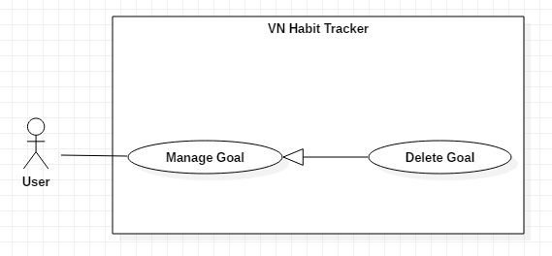

*Figure 14 - <User> Delete habit*

**Use Case Specification**

|  |  |  |  |
| --- | --- | --- | --- |
| **USE CASE – UC_0** | | | |
| **Use Case No.** | 0 | **Use Case Version** | 1.0 |
| **Use Case Name** | Delete goal | | |
| **Author** | TungPT | | |
| **Date** | 07/10/2018 | **Priority** | Normal |
| **Actor:**   * User   **Summary:**   * This use case allows the user to delete goal.   **Goal:**   * Delete a goal from the goal.   **Triggers:**   * User click on “Delete goal” button.   **Preconditions:**   * Guest must login.   **Post Conditions:**   * **Success:** System shows “Successful to delete a goal!” message. * **Fail:** System shows “Failed to delete a goal!” message.   **Main Success Scenario:**   |  |  |  | | --- | --- | --- | | Step | Actor Action | System Response | | 1 | User click on “Delete goal” button. | Shows a form to ask user want to delete goal. | | 2 | User click on “OK” button | - The system validates the request and shows the added information.  [Exception 1] | | 3 | User click on “Save” button | - That goal will be deleted. |   **Alternative:**   |  |  |  | | --- | --- | --- | | No | Actor Action | System Response | | 1 | User click on “Cancel” button. | - Close this form. |   **Exceptions:**   |  |  |  | | --- | --- | --- | | No | Cause | System Response | | 1 | None of any goal was selected | Shows “Failed to add a goal!” message. |   **Relationships:**  N/A  **Business Rules:**   * When a user deleted a goal, this goal will be hidden. * The information of the goal is deleted to the local. | | | |

*Table 24 – Delete goal*

* + 1. <User> Edit goal

**Use Case Diagram**

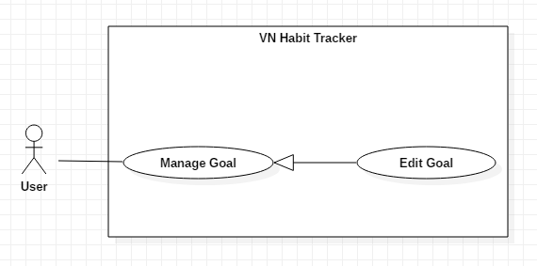

*Figure 15 - <User> Edit habit*

**Use Case Specification**

|  |  |  |  |
| --- | --- | --- | --- |
| **USE CASE – UC_0** | | | |
| **Use Case No.** | 0 | **Use Case Version** | 1.0 |
| **Use Case Name** | Edit goal | | |
| **Author** | TungPT | | |
| **Date** | 07/10/2018 | **Priority** | Normal |
| **Actor:**   * User   **Summary:**   * This use case allows the user to edit goal.   **Goal:**   * Edit a goal from the goal.   **Triggers:**   * User click on “Edit goal” button.   **Preconditions:**   * Guest must login.   **Post Conditions:**   * **Success:** System shows “Successful to edit a goal!” message. * **Fail:** System shows “Failed to edit a goal!” message.   **Main Success Scenario:**   |  |  |  | | --- | --- | --- | | Step | Actor Action | System Response | | 1 | User click on “Edit goal” button. | The system request information in form:   * Goal period: select input * Set your goal: input text | | 2 | User click on “OK” button | - The system validates the request and shows the added information.  [Exception 1] | | 3 | User click on “Save” button | - That goal will be edit. |   **Alternative:**   |  |  |  | | --- | --- | --- | | No | Actor Action | System Response | | 1 | User click on “Cancel” button. | - Close this form. |   **Exceptions:**   |  |  |  | | --- | --- | --- | | No | Cause | System Response | | 1 | None of any goal was selected | Shows “Failed to edit a goal!” message. |   **Relationships:**  N/A  **Business Rules:**   * The goal name must be under 255 characters and not null. * The information of Goal is sent to the server. * After Edit goal success. The user will return to the menu list habit page. | | | |

*Table 25 – Edit habit*

1. **Software System Attribute**
   1. Usability

* Provide a convenient way to interact with system.
* Screen layout and navigation are clear and easy to use.
* Interface are simple and clear, user can easy to manage habit and goal.
* Icons that indicate the actions should be easy to understand and users will not meet any troubles to recognize the feature of application.
  1. Reliability
* This application can run at the same time 100 users.
* The number of sending notification failure is 1 time per 200 notifications.
* The data should be backed up every day.
  1. Availability
* Website available 24/24.
* User connect internet to login.
* User uses offline after login and connect internet to push data to the server.
  1. Security
* Private: Each role of user has a specific permission to interact with the system.
* System always checks authorization and authenticated before doing function of user and admin.
* Only admin can manage user and feedback of user.
  1. Maintainability
* The code is easy to maintain and upgrade.
* Maintain the whole system every 1 months.
* Accidental problem will be resolved within acceptable time.
  1. Portability
* The website is running on Windows 7 or above.
* The mobile application running on a device with API 23 or above.
  1. Performance
* All requests are handled in maximum time of 5 seconds.

1. **Conceptual Diagram**

